Advance SQL Assignments
Database: MySQL

Assignment-1

1 -Higher Than 75 Marks :

Problem : Query the Name of any student in STUDENTS who scored higher than 75 Marks. Order your output by the last three characters of each name. If two or more students both have names ending in the same last three characters (i.e.: Bobby, Robby, etc.), secondary sort them by ascending ID.

Input Format
The STUDENTS table is described as follows:

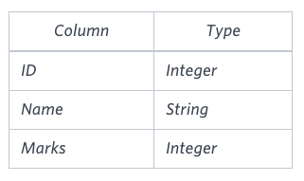
The Name column only contains uppercase (A-Z) and lowercase (a-z) letters.

Sample Input
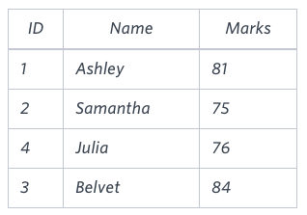

Sample Output:
Ashley
Julia
Belvet

